***Inglés para Negocios I***

***Alumno:*** *Manuel Enrique*

*Ramirez Lopez*

***Modulo 6***

***Actividad 1***

***Actividad 1***

***Unidad 6***

***Fecha de entrega:***

*02/02/2022*

***Indice***

Desarrollo 1

Capturas de pantalla 2

Conclusión 6

# 

# ***Desarrollo***

# First paragraph: write a general description of the template highlighting three elements.

Its navigation is quite fluid, in terms of the type of adaptation that I use to be used on mobile devices and computers, each one is similar with its advantages and disadvantages.

-responsive

-adaptive

-colometry

# Second paragraph: write three advantages of the template in comparison with the current website.

The lack of optimization for the correct navigation, small errors can be seen when browsing the website

-Limited system

-Bad optimization

-Repetitive grouping

# Third paragraph: write three disadvantages of the template in comparison with the current website.

The lack of optimization for the correct navigation, small errors can be seen when browsing the website

-Limited system

-Bad optimization

-Repetitive grouping

3.Fourth paragraph: write a conclusion suggestion with one decision.

# Each page or website has its advantages and disadvantages, we cannot say that this page is perfect because it will have some flaw or it will not be to everyone's liking, as the example that we saw in this activity there is a great variety of designs and styles, but if you want something that is very yours or you don't like the available ones, you can create one with the knowledge you have.

# ***Capturas de pantalla***

# 

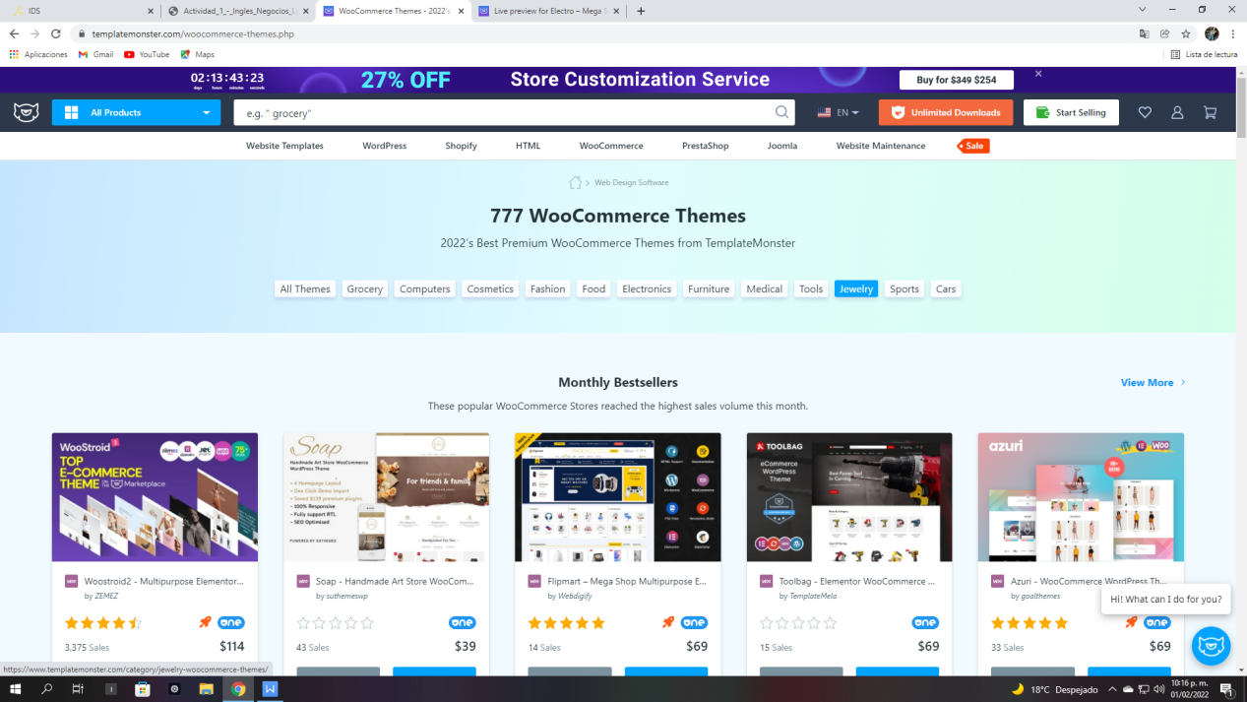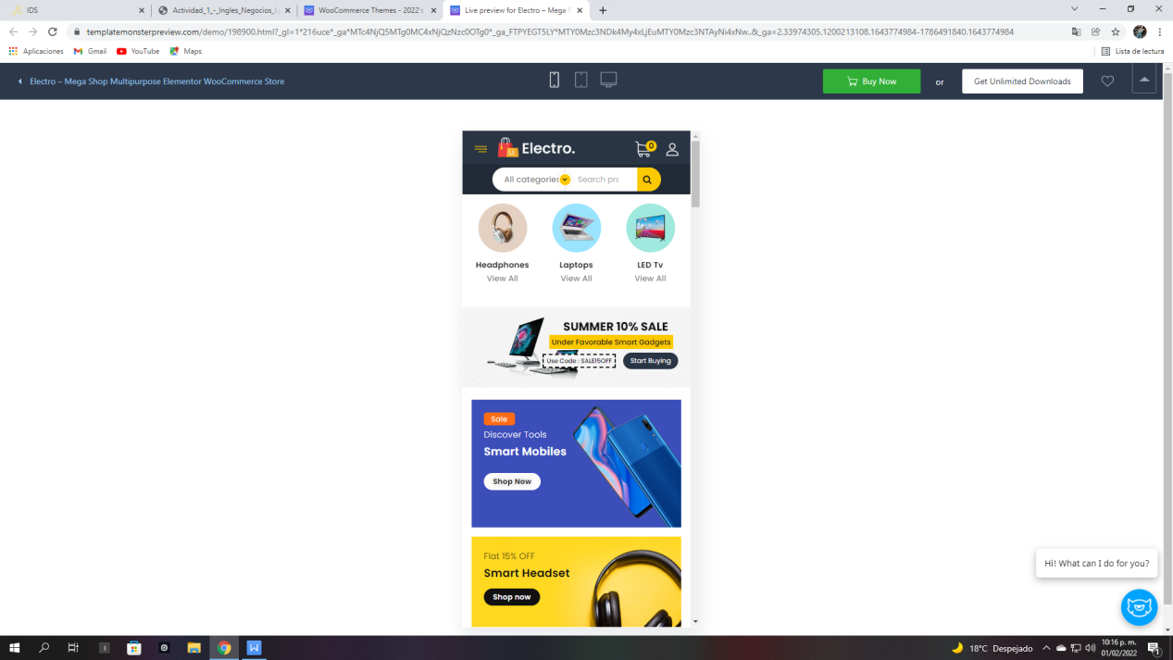

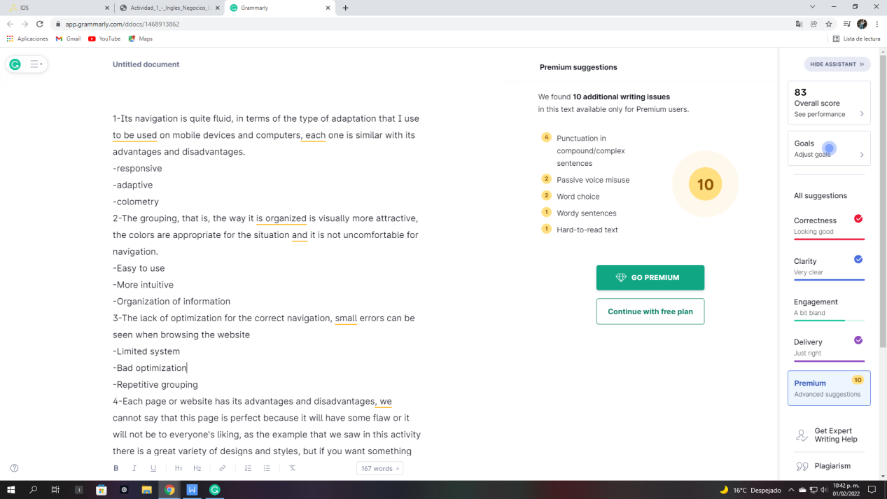

# ***Conclusión***

There are different ways to see or use a web page, where we have the option of using templates as in the activity that was carried out, it also provided us with the experience on the themes that a web page can have.Attached to this we must have the ability to know how to distinguish elements that stand out and elements that do not so that changes are generated for the better and it is a "trend" for having elements that other sites do not have.